Language and Literacy
Early literacy includes materials and activities that prepare the child for writing and reading. Songs, poems, rhyming games, creative materials, story sacks, circle times and pre-literacy listening games each help the children to enrich their vocabulary and to begin to recognise individual sounds and tones. These activities also help to develop the child’s recall, memory, confidence to speak and ability to articulate their own ideas whilst fostering a growing interest in the written word.

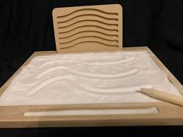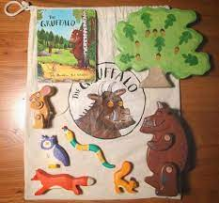

The Language Materials enable the children to practise mark making, using words for meaning, pencil control and phonics as they use materials such as the insets for design, sandpaper letters, large moveable alphabet and the ‘eye spy’ box.

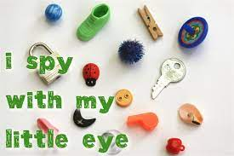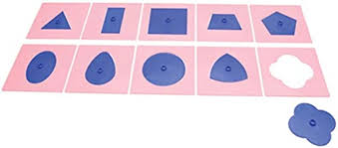

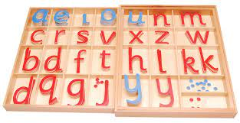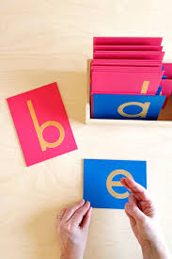
Practical Life Activities
Practical life activities help children to become independent in their daily life and develops their self confidence and self esteem as they learn self care (hand washing, dressing oneself), care of the environment (table setting, sweeping), and develop a sense of completion and order.
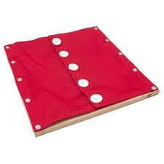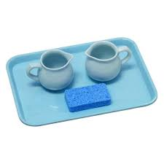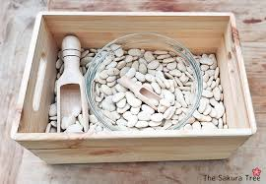

The Practical Life area includes many items the child is used to seeing at home and by using jugs to pour, tongs and spoons to transfer, threading beads, manipulating tools and everyday objects, the children begin practising their pencil grip, start to build up their concentration, learn to persevere, repeat new tasks until they have mastered a new skill, take care of the environment and refine their hand-to-eye co-ordination.
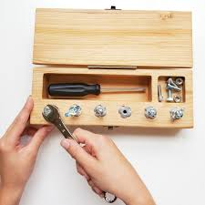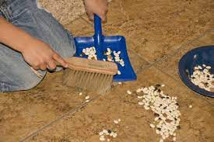
“Education is a natural process carried out by the child and is not acquired by listening to words but by the experiences in his environment.”
Sensorial and Maths Activities
The materials contained in the Sensorial area are designed to be explored with all five senses. Each material isolates one concept at a time such as colour, weight, shape, texture, size, sound and smell. We believe that ordering, comparing and classifying by using the senses is greatly beneficial for the child’s intellectual development, perception, basic problem solving, abstract learning, observational skills and self correction.
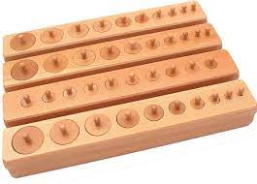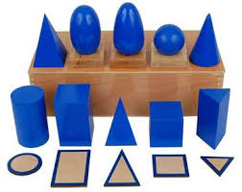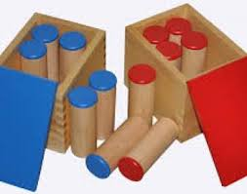
By stimulating the child’s senses and encouraging them to concentrate, the use of the ‘Sensorial’ apparatus lays good foundations for their later language and mathematics work. The sensorial materials introduce the basics of mathematics into the child’s learning by enabling them to count, sort, combine, match, compare and learn to understand mathematical concepts as they explore.
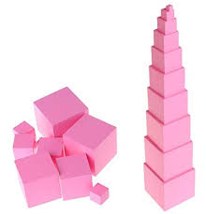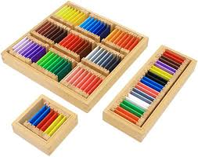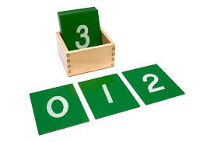
“The environment must be rich in motives which lend interest to activity and invite the child to conduct his own experiences.”

